**[ST10315122] – [Nikhil Rajkumar] – WEDE5021 – POE – Part 1.**

|  |  |
| --- | --- |
| **Cover page:** | **Pg1** |
| **Table of contents:** | **Pg2** |
| **Website choice:** | **Pg3-4** |
| **Website assets:** | **Pg5-10** |
| **Website pages and content:** | **Pg11-16** |
| **List of references:** | **Pg17-18** |

**Table of contents:**

**Website Choice:**

The Digital divide

The digital divide is the gap that exists between people who have access and know how to use and take advantage of modern technology and those who are simple too old to understand how this technology works or they just can’t afford access to the internet. This creates an inequality between people living around the world, giving some people an advantage over others. The “Everyone online” Non-profit organization plans on closing the gap of the digital divide enabling everyone to gain access to the internet which would potentially make a lot of people’s lives much easier. To help people who are less fortunate and do not have the money to be able to afford an electronic device we will be seeking donations of old cell phones and computing devices from the public which would help those in need and address another world issue called pollution. When old electronic devices are disposed improperly, the batteries from these devices contain harmful substances that damage the environment causing air and water pollution. These substances are toxic to plants, animals and people. We will also be hosting fund raising events to help raise the funds needed to support our mission as well as this would help raise awareness to the public about the problem. We will seek help from volunteers in the public who are passionate about closing the gap of the digital divide so that they can help educate people on how to use modern technology and gain access to the internet. Volunteers will help people in need to understand how modern technology works and will help train people. In some areas people do not have access to the internet because they lack access to proper hardware that would allow them to access the internet, so we have secured partnerships with big internet service providers in various areas to sponsor people with the equipment then need to access the online world. Peaceful events such as educational and sports events will be done to help various ISPs to understand what our mission is so that they can reduce the prices of technological devices and internet services. All this would contribute to getting everyone the ability to benefit from the advantages of modern technology.

**Website assets:**

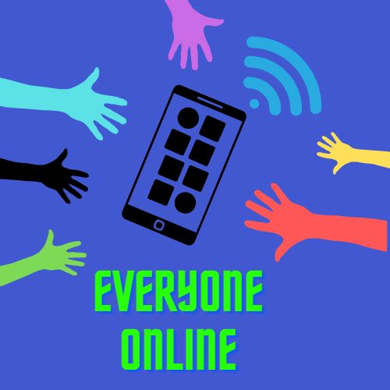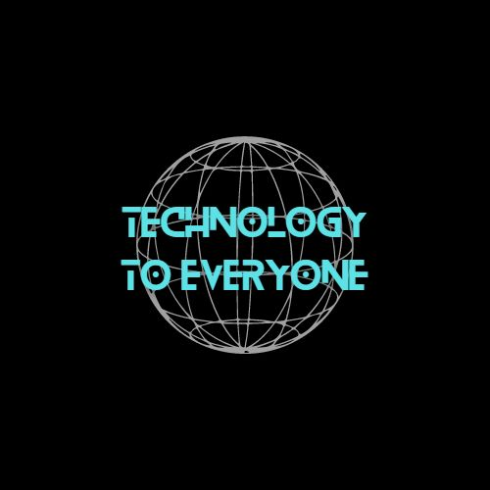

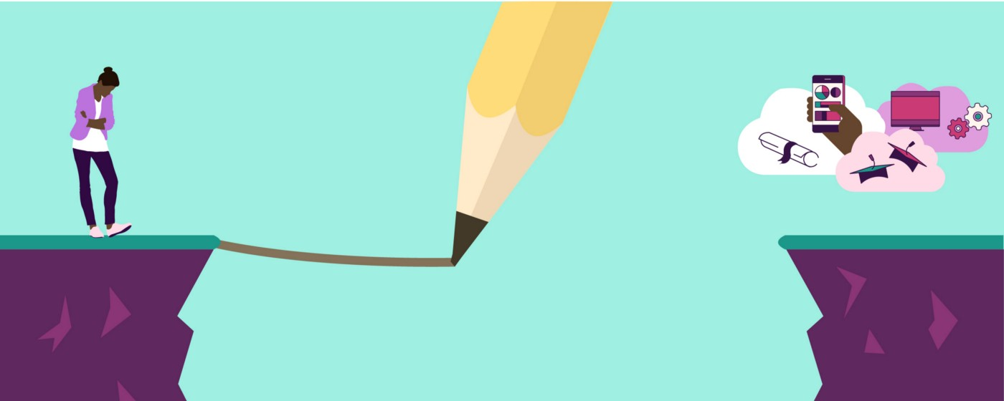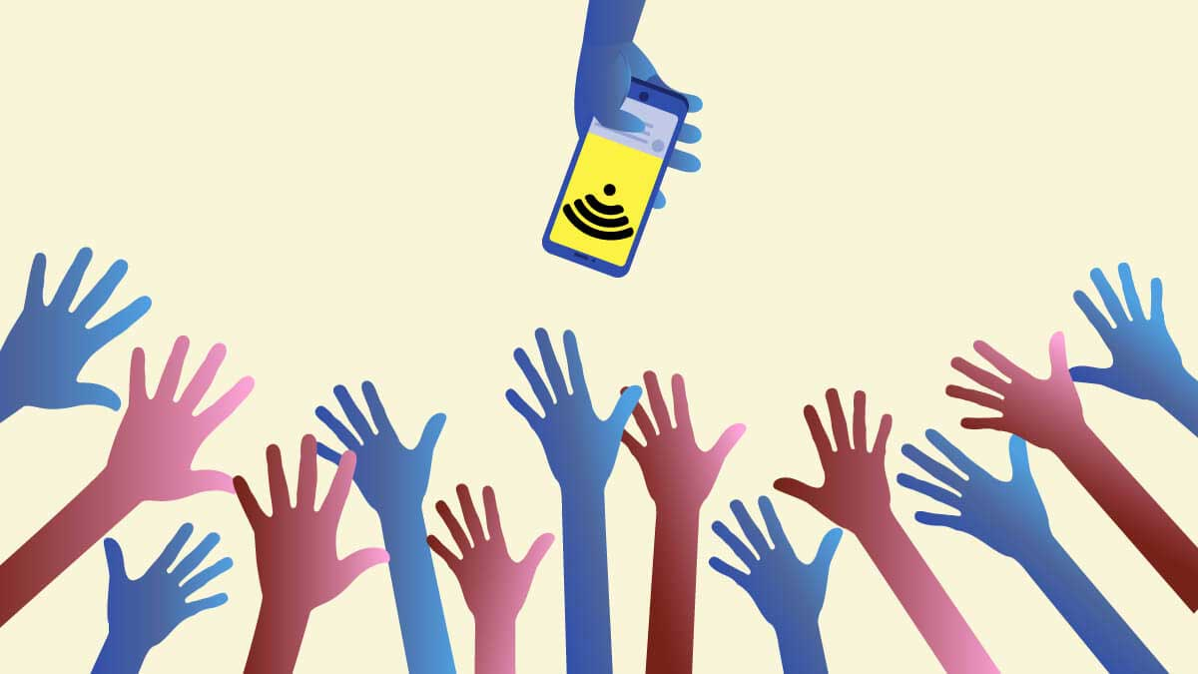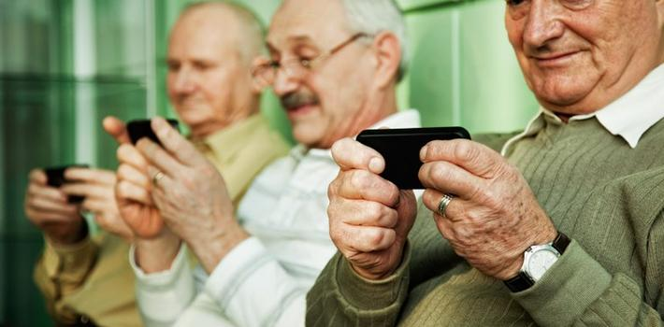

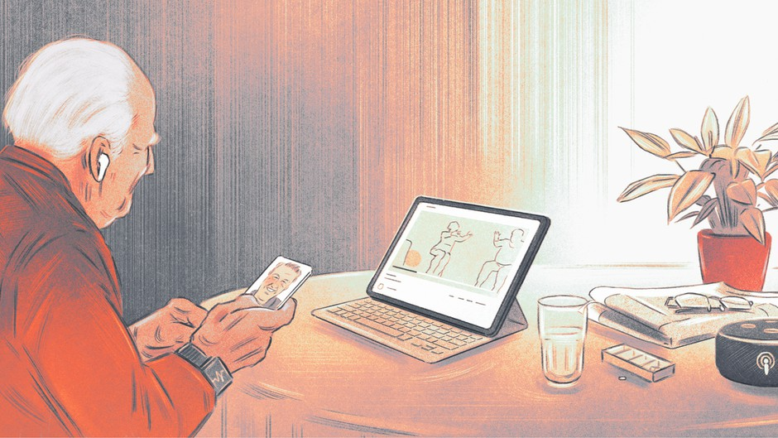

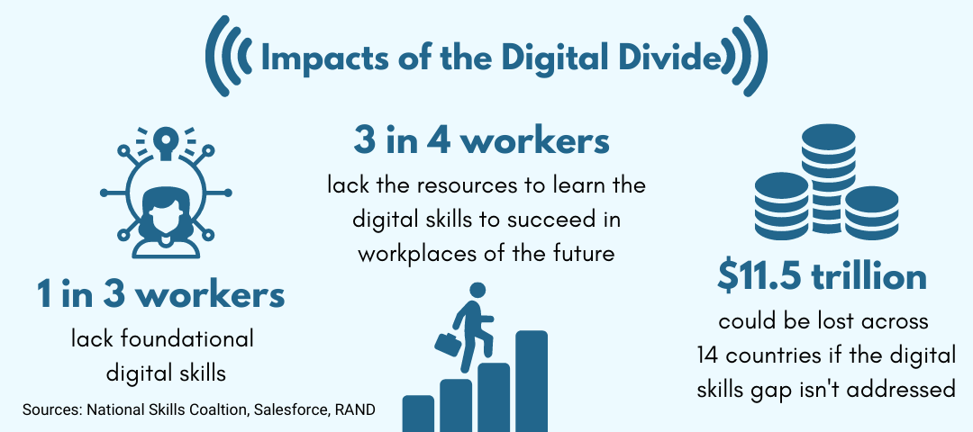

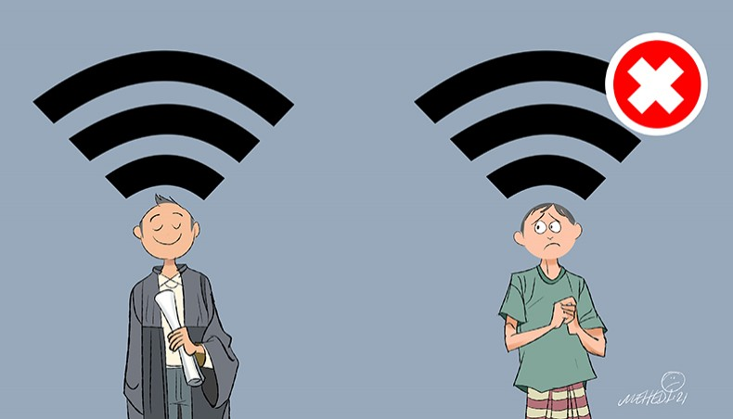

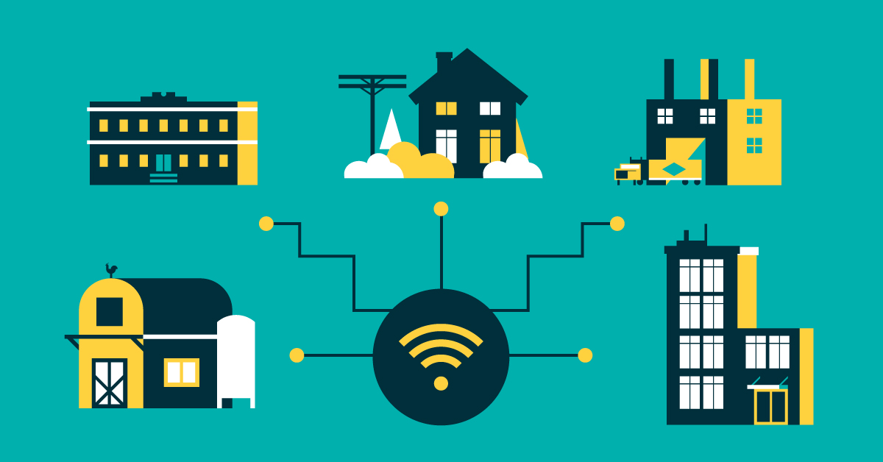

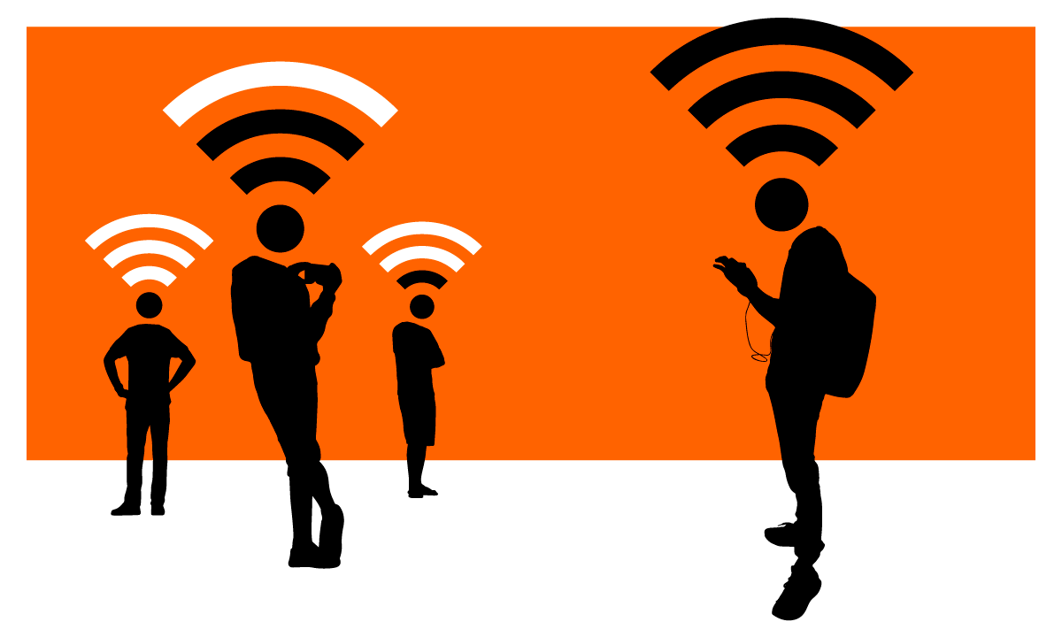

**Webpages and content:**

**Home page:**

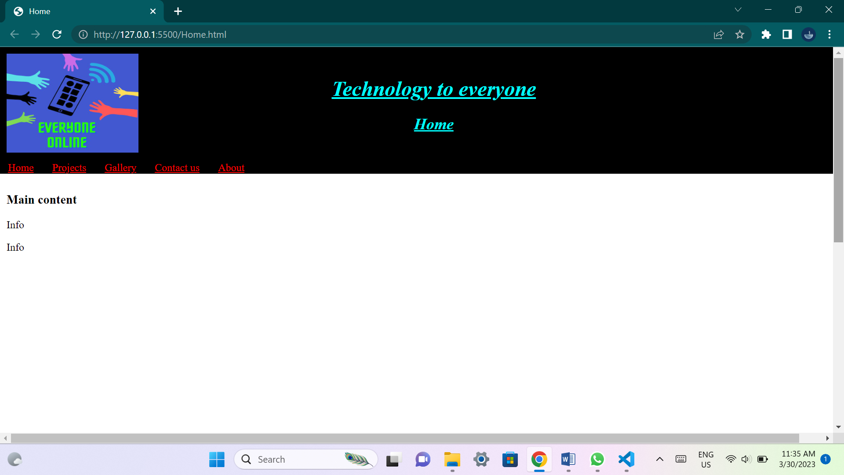

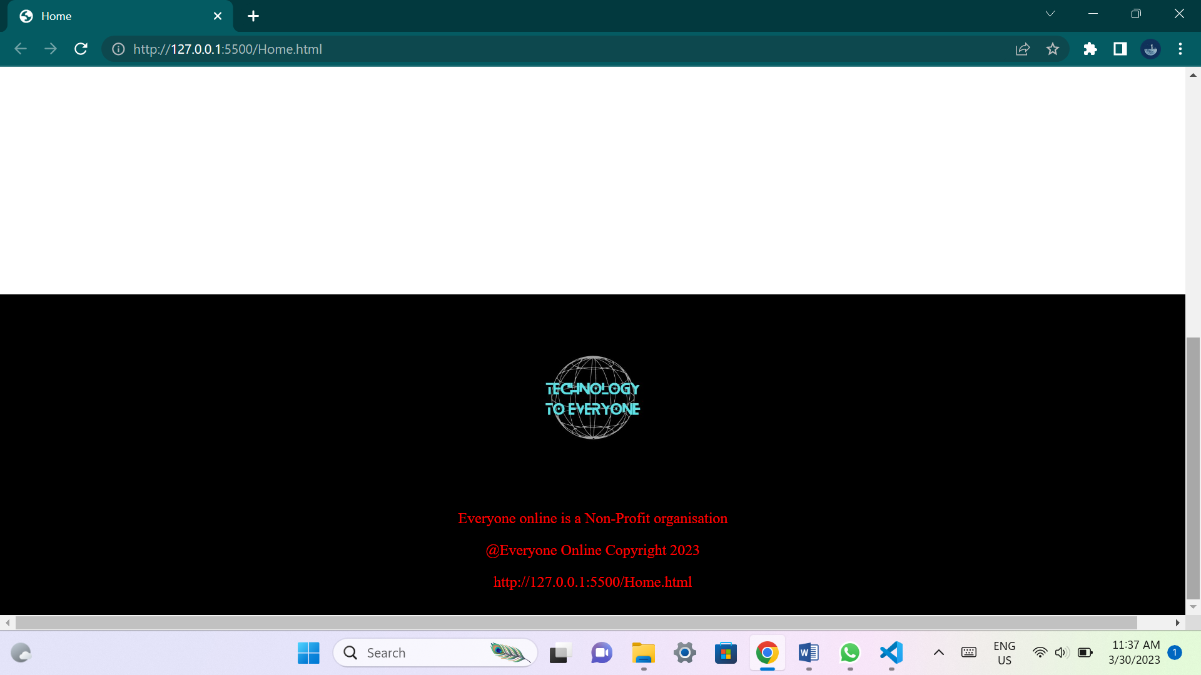

**This page will outline brief details about the organization and its plans. It will include summarized details about all the other web pages.**

**Projects page:**

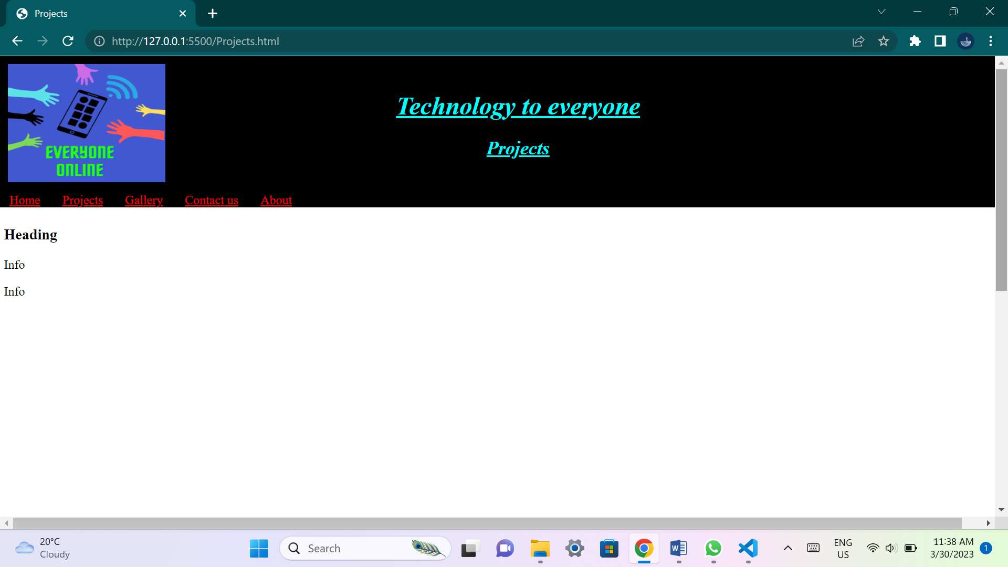

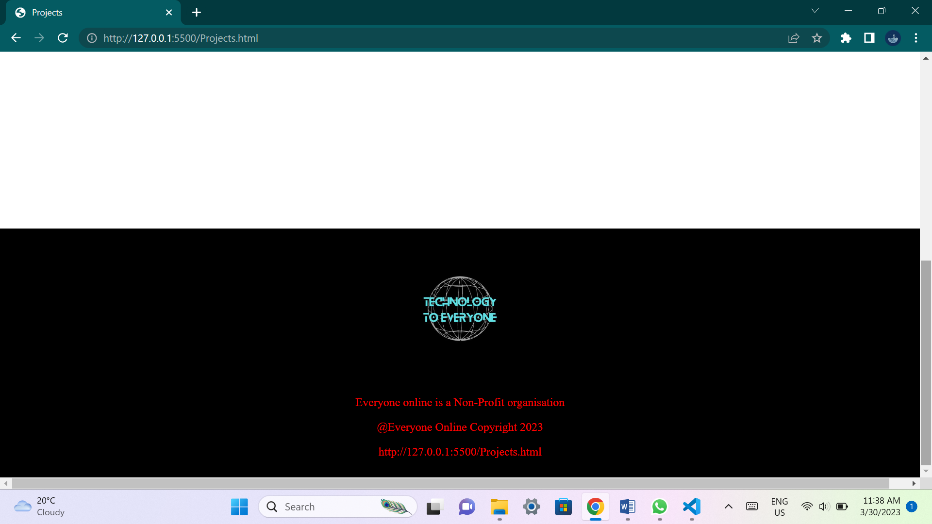

**This page will have images and details about projects that the organization is currently pursuing and wishes to accomplish.**

**Gallery page:**

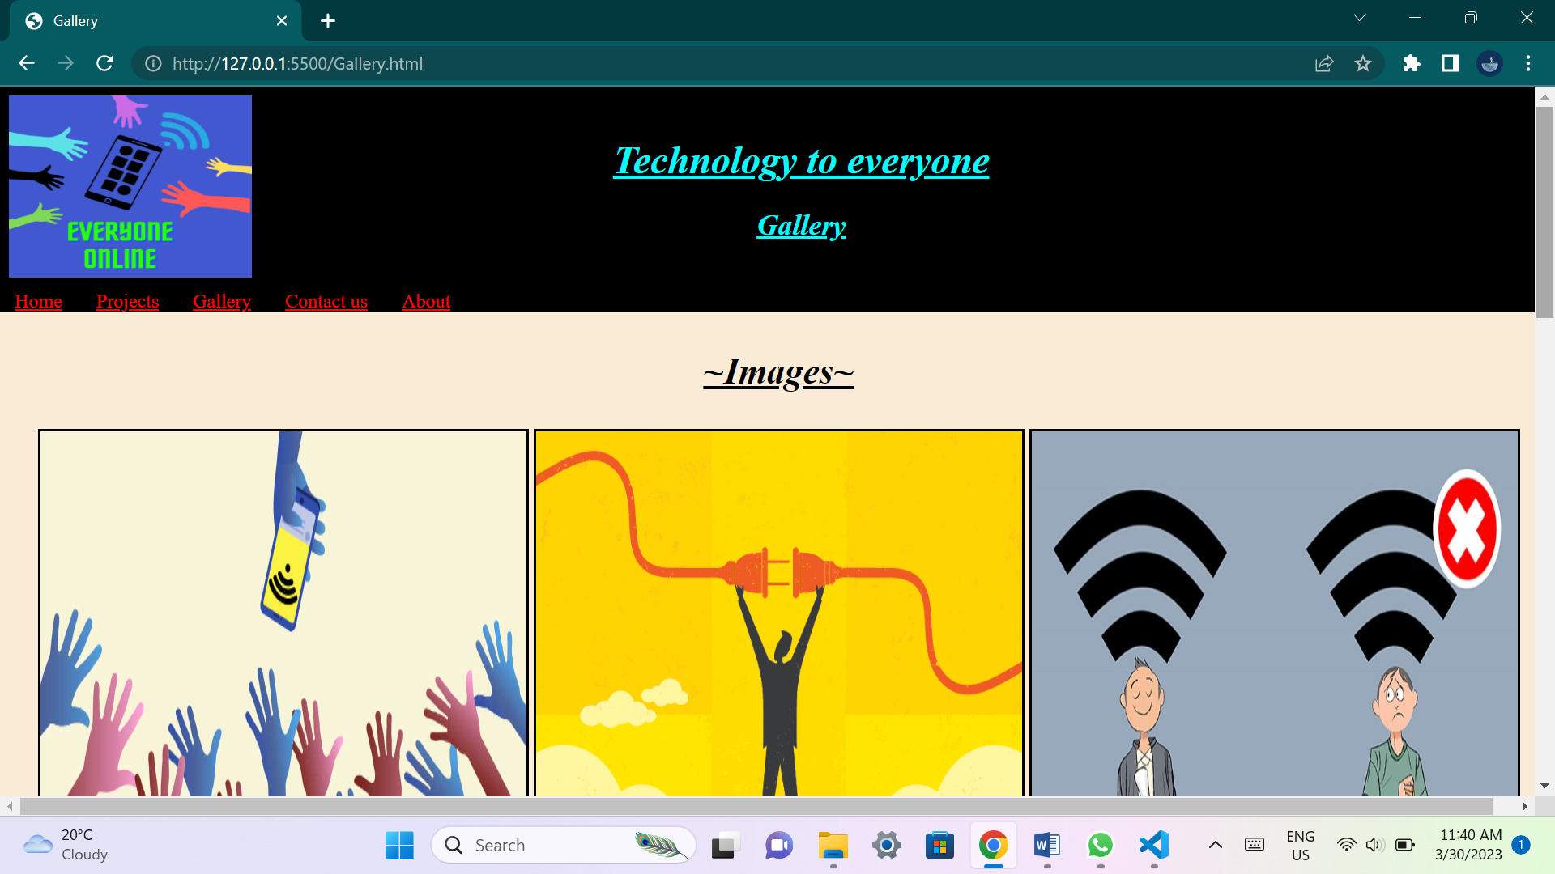

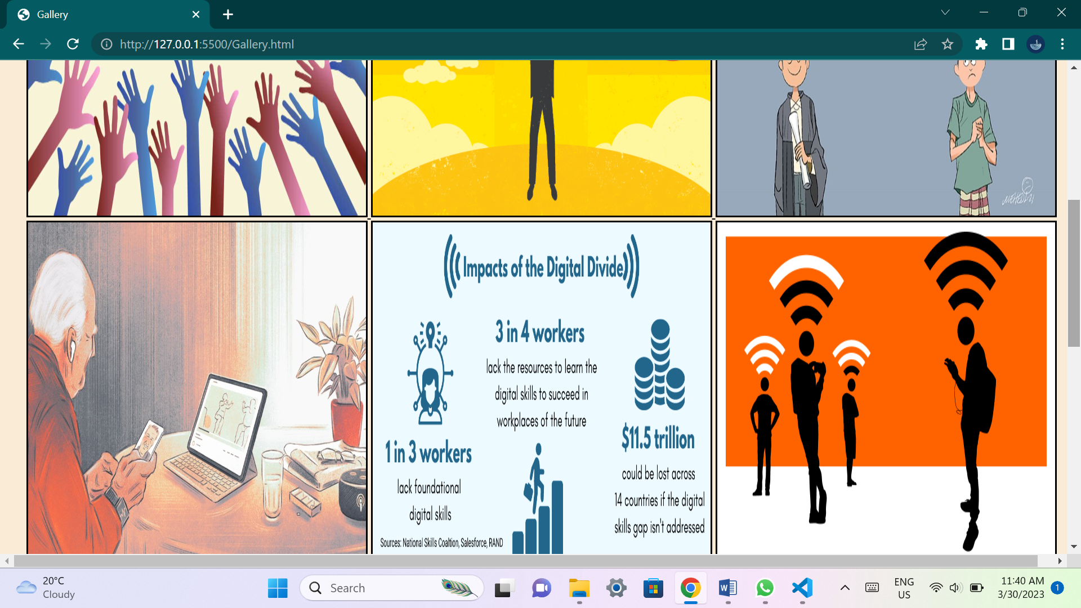

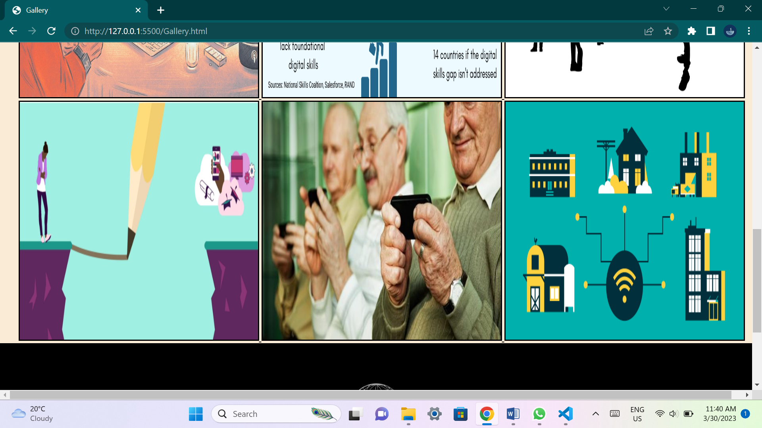

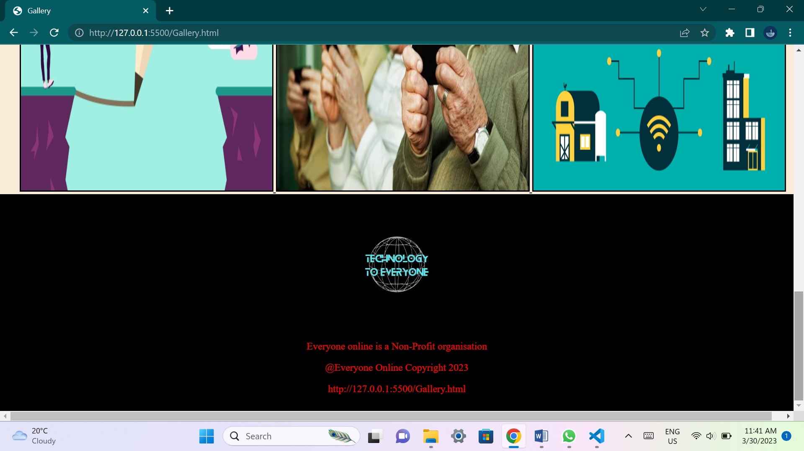

**This page will contain multiple images that would help the user understand what the organization wishes to achieve and its idea's.**

**Contact page:**

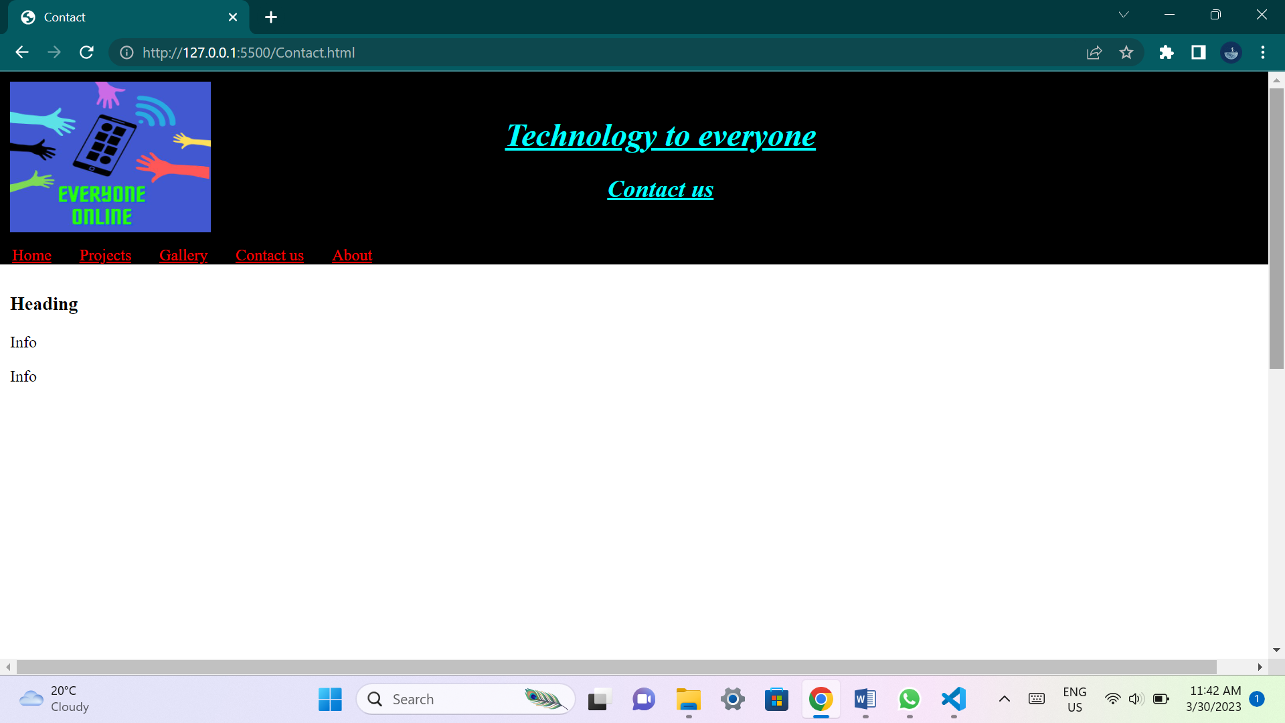

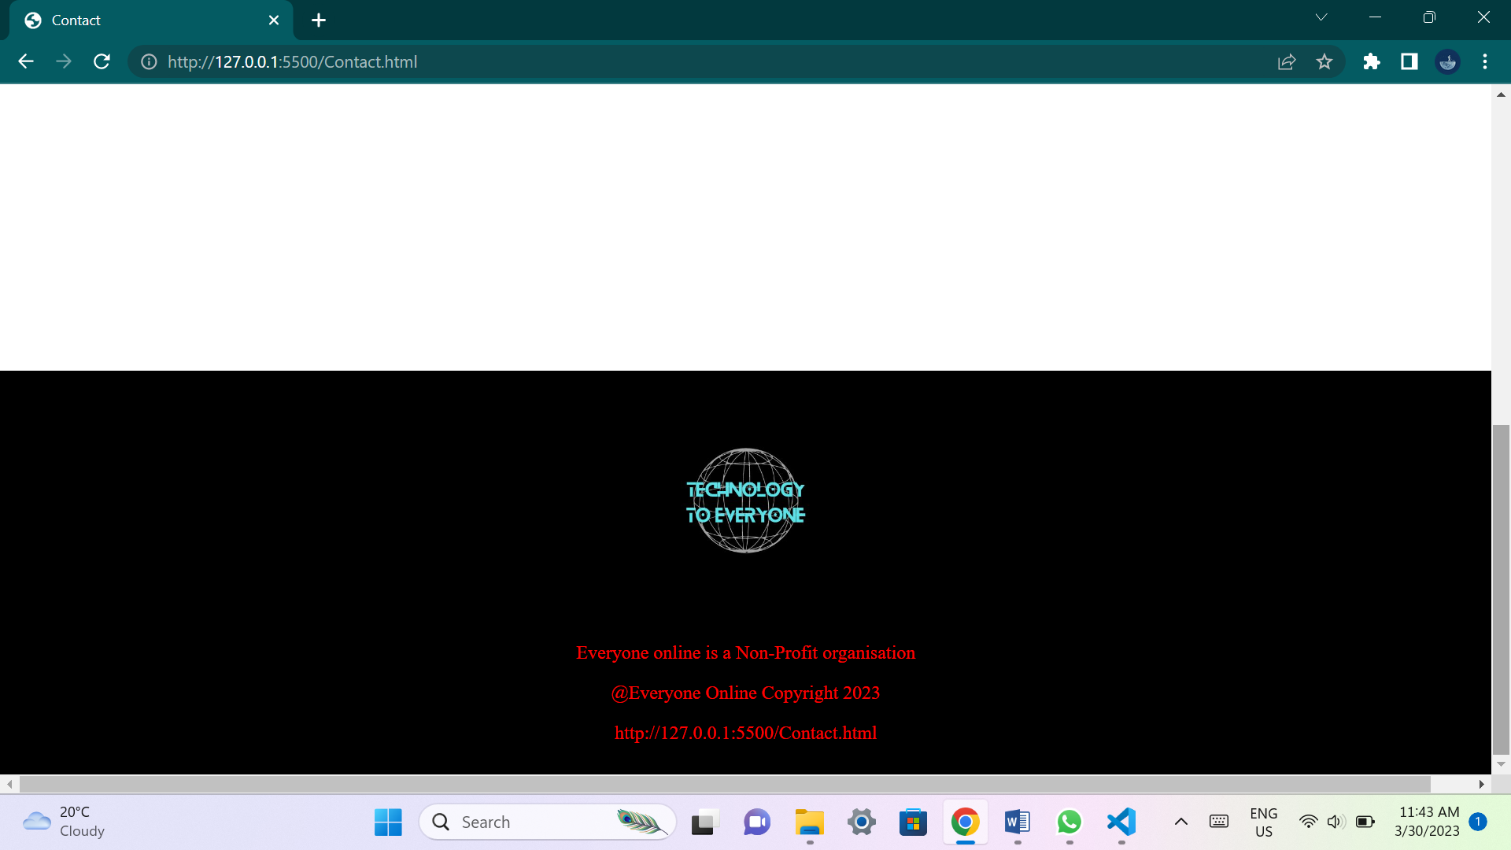

**This page will have contact details that will be available to the user if they have any questions or queries dealing with the organization.**

**About page:**

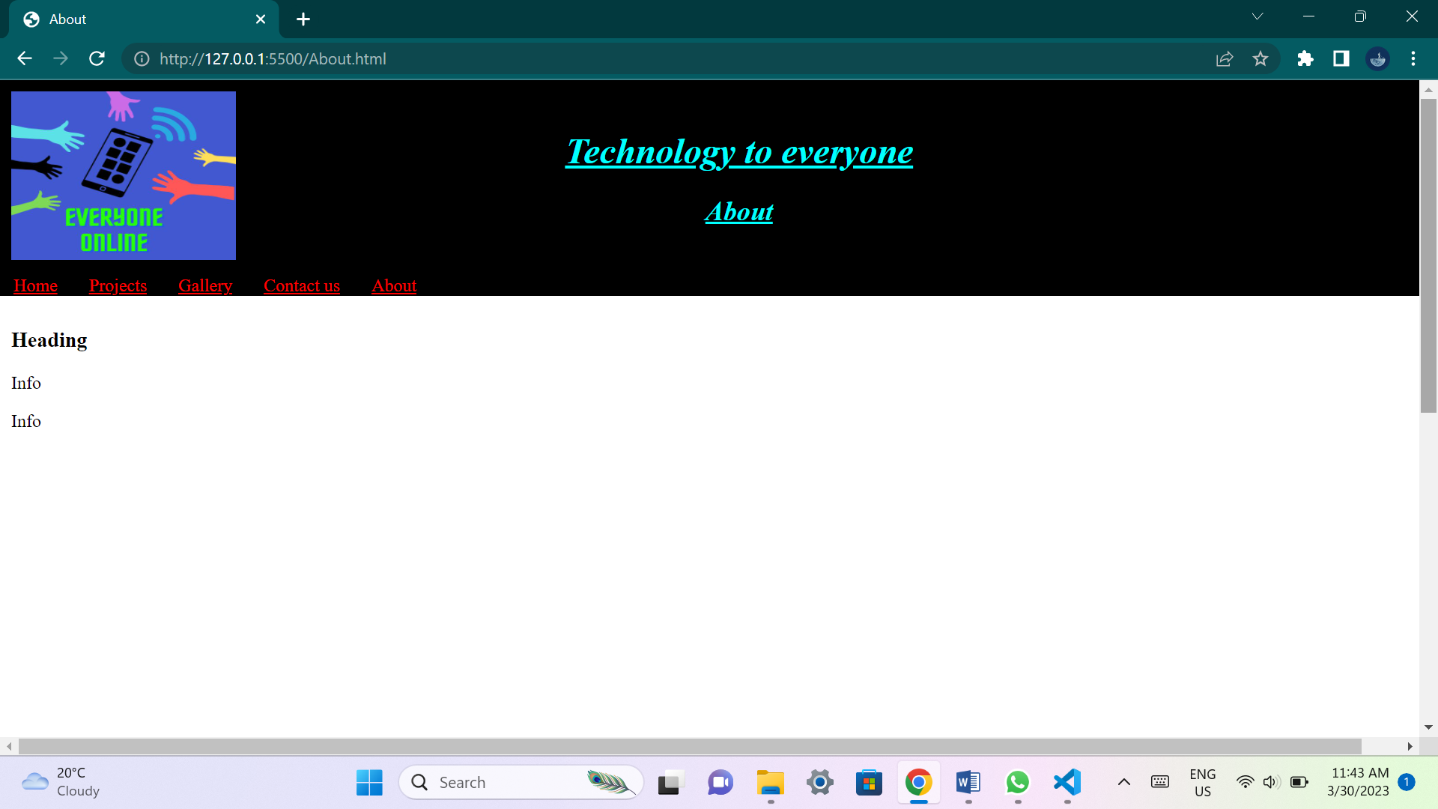

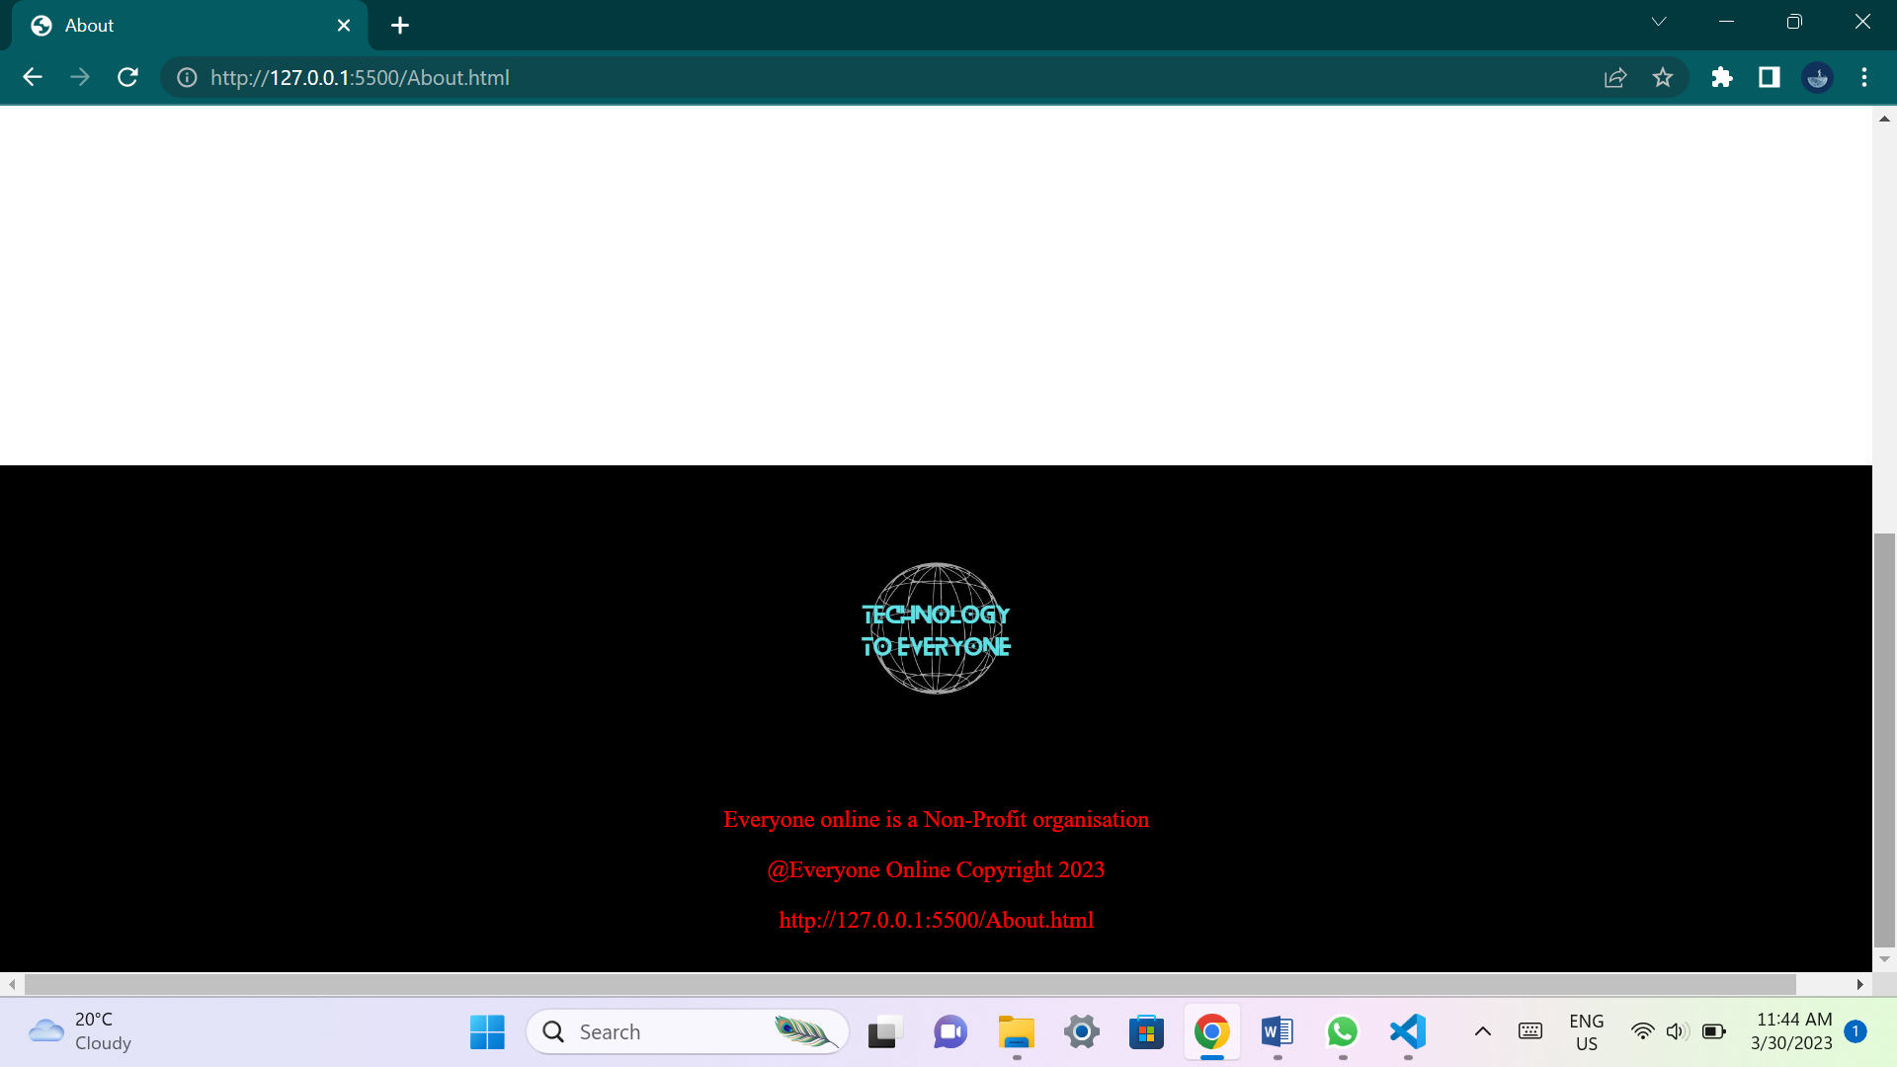

**This page will explain to the user what the organization is about. It will give users an idea about the organization goals and why the organization wants to achieve their goals.**

**List of references:**

* **Rob Amner. 2021. Digital divide narrows as 22 local schools get Wi-Fi, thanks to local tech company. 4 November 2021. [Online]. Available at:** [**https://grocotts.ru.ac.za/2021/11/04/digital-divide-narrows-as-22-local-schools-get-wi-fi-thanks-to-local-tech-company/**](https://grocotts.ru.ac.za/2021/11/04/digital-divide-narrows-as-22-local-schools-get-wi-fi-thanks-to-local-tech-company/) **(Accessed 29 March 2023)**
* **Avnation Organization. 2020. Bridging the digital divide with social activism in AV. 7 August 2020. [Online]. Available at:** [**https://www.avnation.tv/2020/08/07/bridging-the-digital-divide-with-social-activism-in-av/**](https://www.avnation.tv/2020/08/07/bridging-the-digital-divide-with-social-activism-in-av/) **(Accessed 29 March 2023)**
* **Syed Laden. 2021. Digital Bangladesh, digital divide and education sector. 18 April 2021. [Online]. Available at:** [**https://www.newagebd.net/article/135620/digital-bangladesh-digital-divide-and-education-sector**](https://www.newagebd.net/article/135620/digital-bangladesh-digital-divide-and-education-sector) **(Accessed 29 March 2023)**
* **Linda Poon and Sarah Holder. 2020. The ‘New Normal’ for Many Older Adults Is on the Internet. 6 May 2020. [Online]. Available at:** [**https://www.bloomberg.com/news/features/2020-05-06/in-lockdown-seniors-are-becoming-more-tech-savvy**](https://www.bloomberg.com/news/features/2020-05-06/in-lockdown-seniors-are-becoming-more-tech-savvy) **(Accessed 29 March 2023)**
* **Keith Oelrich. 2022. Why We Must Close the Digital Divide. 15 February 2022. [Online]. Available at:** [**https://www.learning.com/blog/closing-the-digital-divide/**](https://www.learning.com/blog/closing-the-digital-divide/) **(Accessed 29 March 2023)**
* **Joshua Bay. 2022. Report: Internet Gap Snubs LA Low-Income Residents & Widens Digital Divide. 24 October 2022. Available at:** [**https://www.the74million.org/article/report-internet-gap-snubs-la-low-income-residents-widens-digital-divide/**](https://www.the74million.org/article/report-internet-gap-snubs-la-low-income-residents-widens-digital-divide/) **(Accessed 29 March 2023)**
* **Ally Tech. 2022. Bridging the Digital Divide: Driving Towards Digital Equity & Inclusion for All. 19 August 2022. Available at:** [**https://ally.tech/bridging-the-digital-divide-driving-towards-digital-equity-inclusion-for-all-fb519aaaca0a**](https://ally.tech/bridging-the-digital-divide-driving-towards-digital-equity-inclusion-for-all-fb519aaaca0a) **(Accessed 29 March 2023)**
* **Theodore D Cosco. 2018. Bridging the digital divide amongst older adults. 23 May 2018. Available at:** [**https://www.ageing.ox.ac.uk/blog/digital-divide**](https://www.ageing.ox.ac.uk/blog/digital-divide) **(Accessed 29 March 2023)**
* **Admin. 2020. THE DIGITAL DIVIDE. 6 October 2020. Available at:** [**https://www.rebdones.com/uncategorized/the-digital-divide/**](https://www.rebdones.com/uncategorized/the-digital-divide/) **(Accessed 29 March 2023)**